Big Mountain Resort located near Glacier National Park welcomes around 350,000 skiers and snowboarders every year and sports 105 trails accessible by 13 lifts that provide access to 3000 skiable acres. This year an additional 14th lift was added to increase the distribution of visitors across the resort thus increasing the total operation costs by $1,540,000 and Big Mountain will need to re-evaluate it’s pricing strategy to maximize profits. The recommendation per the modeling data is that the wide array of features and resources available at Big Mountain are undervalued and the ticket price at $81.00 and should be increased to a minimum of $85.48 in the current market.

The data provided was a complete list of all major ski resorts in the United States that contain multiple variables including (but not limited to) number of chair lifts, longest run, snow making capabilities. The data was organized and cleaned to ensure that future modeling results would be as accurate as possible. Initial exploration of the data revealed a strong correlation between some features such as night skiing area relationship with resorts per capita. The heat map below shows all these correlations in more detail.

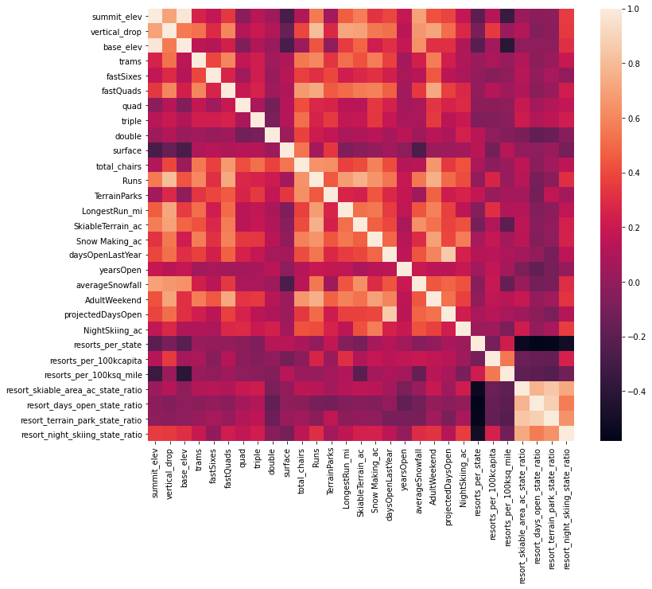

One result that was very counterintuitive was that the more chair lifts a resort has to move people around, relative to the number of runs, ticket prices tend to be lower. This may stem from an exclusive vs mass market effect.

Using the sorted data, a series of training and test data sets were generated to develop pricing models. The first model was a linear type regression that filled in all missing data values with data median values and was able to predict ticket pricing with a possible error of around $19. After attention to redefine the linear model, the error increased and based on the number of variables overfitting was suspected. An alternate model utilizing a random forest regression combined with cross-validation appeared to the best results with a mean absolute error of around 9.53. This method submized that the dominant four traits were fast quads, number of runs, snow making per acre and total vertical drop.

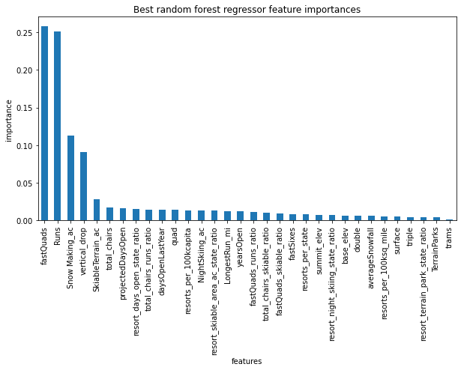

The random forest model was then refitted on the entire data set to determine the and Big Mountain’s predicted ticket price at $95.87. WIth a possible error of $10.39 there is a room for increase to ticket price to a minimum of 85.48 to increase the upcoming year’s revenue. Additional scenarios include decreasing the number of runs by 5 to reduce overhead costs with the smallest impact to modeled ticket pricing. An alternative to this is a scenario in which an additional lift would make way for a new run at the top of the mountain and increase the total vertical drop by 150 feet. This option would support an additional $1.99 increase to ticket pricing and bring in an estimated 3.47 million dollars.